**Question 1**

Implement the program below using Java

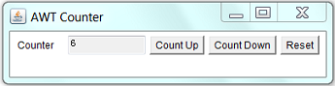

**Question 2**

Implement the interface below with Java Swing

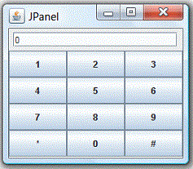

**Question 3**

Write a program that creates a user interface to perform integer division. The user enters two numbers in the text fields, Num1 and Num2. The division of Num1 and Num2 is displayed in the Result field when the Divide button is clicked. If Num1 and Num2 were not integers, the program would throw a Number Format Exception. If Num2 were zero, the program would throw an Arithmetic Exception Display the exception in a message dialog box

**Question 4**

